Submitting assignments to Brightspace
_______________________________________
Before submitting your Google Doc Booklets to Brightspace you FIRST must provide access to your teacher

If you do not your teacher will be UNABLE to review your work AND grade your exams

Here are the steps on how to provide access:
(Note you will see these attached to each booklet as well)

Step 1: Click the blue Share button (top right corner of the document)

Step 2: Under Get Link, click Change

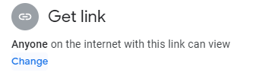

Step 3: Where it says Viewer, click the dropdown and change it to Editor.

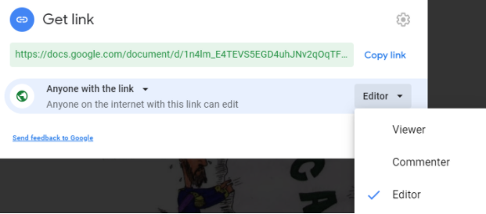
Step 4: Click Copy Link

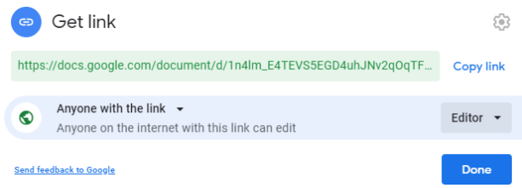

Step 5: Below, paste the link you copied into the space using CTRL+V or Right click+paste

Step 6: Hit Submit

